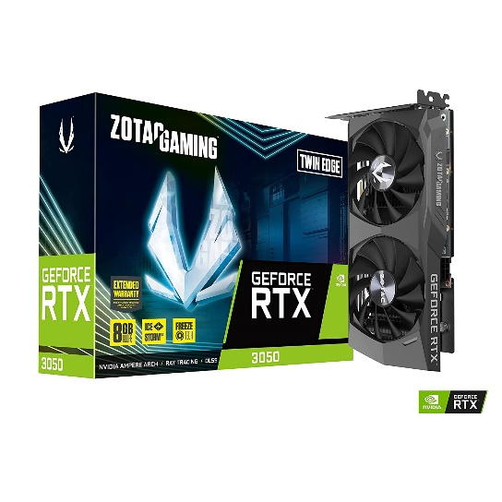

Inner

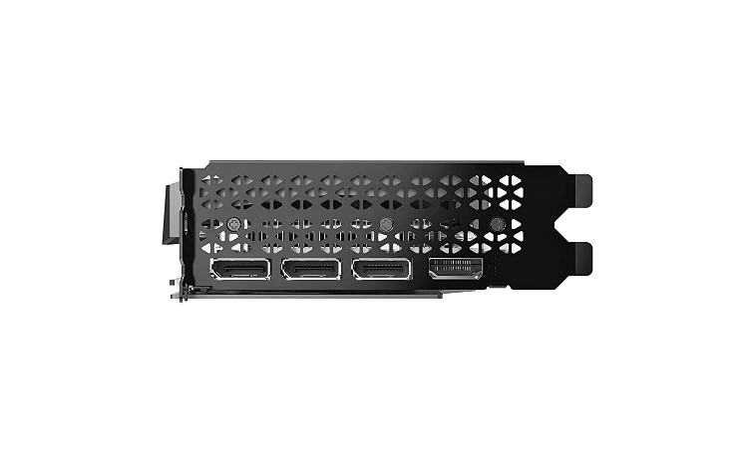

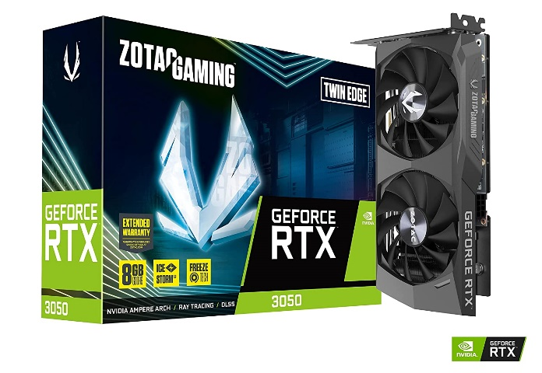

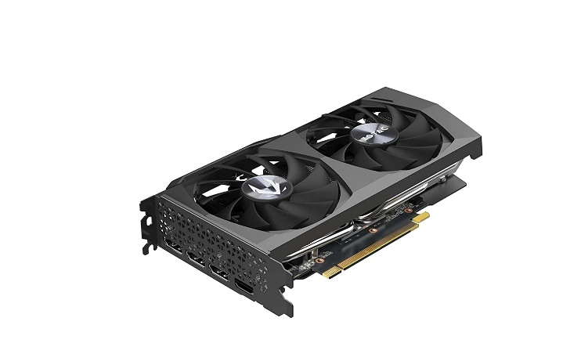

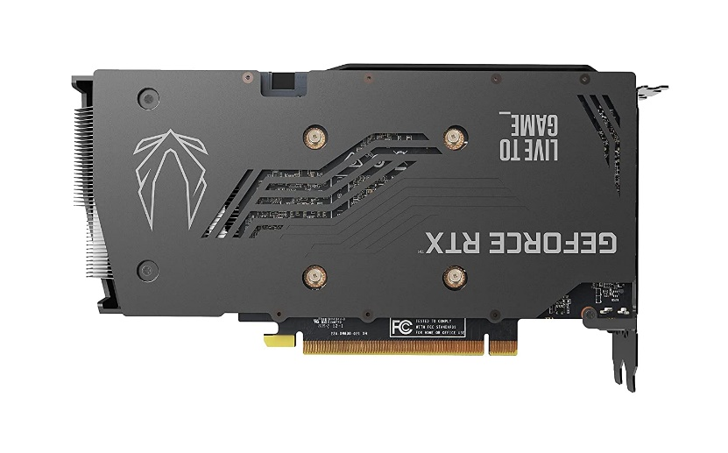

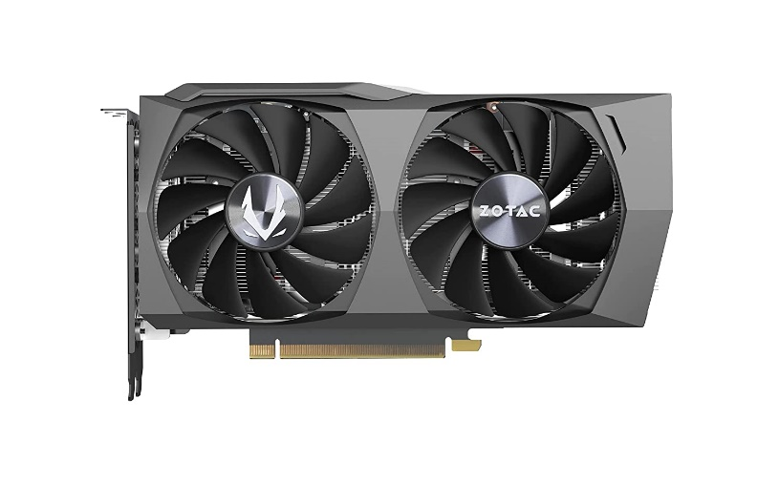

Zotac Gaming GeForce RTX 3050 8 GB GDDR6 Twin Edge Graphics Card, Black, pci_e_x4

|  |  |
| --- | --- |
| M.R.P.: | ₹48,100 |
| Deal of the Day: | ₹28,421   |  |  | | --- | --- | | Graphics Coprocessor | NVIDIA GeForce RTX 3050 | | Brand | Zotac | | Graphics RAM Size | 8 GB | | GPU Clock Speed | 1777 MHz | | Video Output Interface | DisplayPort, HDMI |   **About this item**   * Asus ROG Strix GeForce RTX 3050 OC Edition comes with DirectX 12 Ultimate OpenGL4.6 for 3D rendering and video editing. It can be installed on Many Motherboards that support PCIE 4.0 Slot for Memory Bandwidth upto 224GB/s. * Asus ROG Strix GeForce RTX 3050 OC Edition is the most premium series in Graphic card industry with the best components and after sales service. * Asus ROG Strix GeForce RTX 3050 OC Edition comes with 8GB of GDDR6 RAM and Single Fan for Ultimate performance while Gaming on AAA Games for Gamers, Generating a good revenue while Mining Cryptocurrency for Miners and ofcourse 4k editing for Video Editors and content creators * Asus ROG Strix GeForce RTX 3050 OC Edition has Nvidia Ampere Arch, Ray Tracing, DLSS and support for Nvidia G Sync and GPU Boost for the best gaming experience on PC Computer or Desktop.You can play all AA Games such as Forza horizon 5, Call of Duty, Counter Strike Go, Fortnite Valorant, Doom Eternal, Shadow of the Tomb Raider, GTA 5, Red Dead Redemption 2 or RDR2 at good frame rates. * Asus ROG Strix GeForce RTX 3050 OC Edition 8GB comes with 3 Years Warranty directly from Brand authorised service centres for peace of mind while long hour operations. Suggested Power Supply is 550W |